

Track Metrics Limited

Carbon Reduction Plan

Publication date: 03/01/2024

**Contents**

Commitment to achieving Net Zero 3

Baseline Emissions Footprint 3

Data 4

Assessment 4

Data improvement plan 5

Emissions reduction targets 5

Completed carbon reduction projects 6

Future carbon reduction initiatives 6

Declaration and Sign Off 6

Appendix – Calculations 7

Scope 3 7

# Commitment to achieving Net Zero

Track Metrics Limited is committed to achieving Net Zero emissions by 2045 at the latest.

# Baseline Emissions Footprint

Baseline emissions are a record of the greenhouse gases that have been produced in the past and were produced prior to the introduction of any formal strategies to reduce emissions. Baseline emissions are the reference point against which emissions reduction can be measured.

|  |  |
| --- | --- |
| **Baseline Emissions**  **For year:**  01 January 2024- 31 December 2024 | **tCO2e** |
| **Scope 1 –** Direct emissions (from gas and fuel usage) | 0.00 |
| **Scope 2 -** Electricity | 0.00 |
| **Scope 3** |  |
| Waste generated in operations | 0.11 |
| Business travel | 0.85 |
| Employee commuting and home working | 1.13 |
| Employee home working | 6.61 |
| Upstream leased assets | 4.46 |
| **Total Emissions** | **13.16** |
| **Per Employee Emissions** | 1.20 |
| **Additional Details relating to the Baseline Emissions calculations** | |
| The figures in this report refer to emissions under Track Metrics Limited operational control. The conversion factors used are for location-based reporting. Part of this plan is to improve the scope and accuracy of data going forward. All data has been compiled with reference to and using data from:   * https://ghgprotocol.org/corporate-standard * https://www.gov.uk/government/collections/government-conversion-factors-for-company-reporting (2023 and 2024 data set)   The figures and information used in calculations have been provided as accurate to the best of our knowledge and as far as practicable we have assumed that figures are representative of our operations. We undertake a continual process of improving our data quality. In the case that we identify any material changes, we may recalculate the data in the future.  * From source data, eliminating rounding errors from breakdown | |

**Current Emissions Reporting**

As baseline

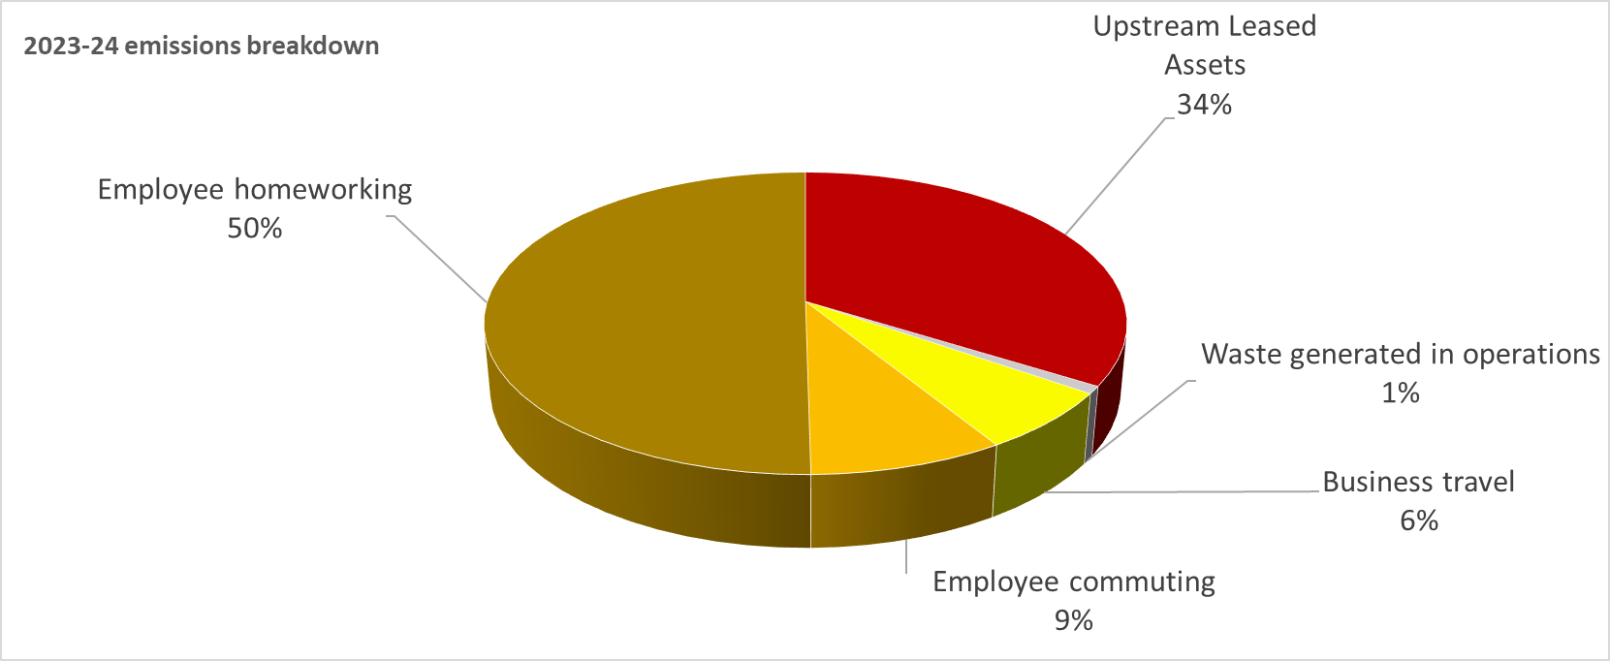

# Data

## Assessment

|  |  |  |
| --- | --- | --- |
| **Scope / category** | **Relevance**  (materiality based**)** | **Data quality**  (1 = certain,  5 = uncertain) |
| **Scope 1** – Natural gas | Not applicable | - |
| **Scope 1** – Company fuel | Not applicable | - |
| **Scope 1** – Fugitive emissions | Not applicable | - |
| **Scope 2** - Electricity | Not applicable | - |
| **Scope 3** |  |  |
| 1. Purchased goods and services | No data available this year* | - |
| 2. Capital goods | Not applicable | - |
| 3. Transmission and distribution (gas and electricity) | Not applicable | - |
| 4. Upstream transportation and distribution | No data available this year* | - |
| 5. Waste generated in operations | Low | 4 |
| 6. Business travel | Medium | 3 |
| 7. Employee commuting and homeworking | High | 3 |
| 8. Upstream leased assets | High | 4 |
| 9. Downstream transportation and distribution | Not applicable | - |
| 10. Processing of sold products | Not applicable | - |
| 11. Use of sold products | No data available this year* | - |
| 12. End-of-life treatment of sold products | Not applicable | - |
| 13. Downstream leased assets | Not applicable | - |
| 14. Franchises | Not applicable | - |
| 15. Investment | No data available this year* | - |

* will be reported when data is available

## Data improvement plan

Our ambition is to:

|  |  |
| --- | --- |
| Category | Action |
| 3.1, 3.4, 3.5 | Engage suppliers to encourage and support them to provide emissions data and their own Net Zero plans. |
| 3.6 | Capture business travel distance and mode of travel at time of travel or expense claim |
| 3.7 | Capture commuting data through time and attendance systems |
| Various | Longer term we will work with customers to understand the emissions associated with use of our products and services |

# Emissions reduction targets

In order to progress to achieving Net Zero, we have adopted the carbon reduction targets detailed in the graph below.

These targets will be updated and recalculated as additional Scope 3 categories are added and data quality is improved (if changes create >5% variance in original calculations).

We project that carbon emissions will decrease to circa 9.8 tonnes by 2030. This is a reduction of 25% from our baseline year, on average a 4.2% year on year reduction.

Our reduction path is plotted below.

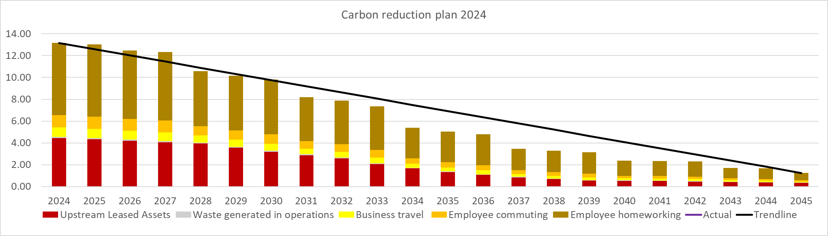

As our footprint is dominated by homeworking, we have assumed reductions from government projected grid electricity decarbonisation and the adoption of lower carbon heating solutions based on current legislation and manufacturer plans.

The plan assumes some unavoidable emissions will remain by 2045, and these will be offset via a verified method of atmospheric CO2 removal.

We anticipate this path will change significantly over time as our options are evaluated and technology changes.

# Completed carbon reduction projects

* No record savings from emission reduction projects in this year.

# Future carbon reduction initiatives

1. Engage employees to educate and where possible support their home energy efficiency and heating transition away from fossil fuel sources.
2. Encourage and incentivise employees to transition to lower carbon vehicles upon replacement; including installation of EV charging points and consideration of EV salary sacrifice schemes.
3. Engage supply chain and landlords to understand and where possible support their carbon reduction plan development and delivery.
4. Engage customers to understand and where possible support their carbon reduction plan development and delivery.

# Declaration and Sign Off

This Carbon Reduction Plan has been completed in accordance with PPN 06/21 and associated guidance and reporting standard for Carbon Reduction Plans.

Emissions have been reported and recorded in accordance with the published reporting standard for Carbon Reduction Plans and the GHG Reporting Protocol corporate standard[1], the Corporate Value Chain (Scope 3) Standard[2].and uses the appropriate [Government emission conversion factors for greenhouse gas company reporting](https://www.gov.uk/government/collections/government-conversion-factors-for-company-reporting)[3].

The Scope 3 emissions reported have been calculated in accordance with the published reporting standard for Carbon Reduction Plans and the Corporate Value Chain (Scope 3) Standard.

This Carbon Reduction Plan has been reviewed and signed off by the board of directors.

#### Signed on behalf of Track Metrics Limited:

………………………………………………………………….Date: ……………………….……….

# Appendix – Calculations

All conversion factors applied to relevant units to generate Kg CO2e, then reported as t CO2e.

## Scope 3

### 3.5 Waste generated in operations

Waste figures estimated from volume of waste collected, with split between incineration, recycling and landfill from waste service provider, using the appropriate conversion factors*.

### 3.6 Business travel

Business travel mileage was calculated applying the relevant conversion factors* to the distances by mode of travel reported.

### 3.7 Employee commuting and home working

Reported commuting distances were multiplied by the relevant mode of travel emissions factors*.

Full time equivalent working hours from home had the relevant conversion factor* applied.

### 3.8 Upstream leased assets - offices

Emissions were calculated from floor area using CIBSE data, and cross referenced with the reported electric heating usage.

* Taken from <https://www.gov.uk/government/collections/government-conversion-factors-for-company-reporting> for relevant years

1. <https://ghgprotocol.org/corporate-standard>
2. <https://ghgprotocol.org/standards/scope-3-standard>
3. <https://www.gov.uk/government/collections/government-conversion-factors-for-company-reporting>